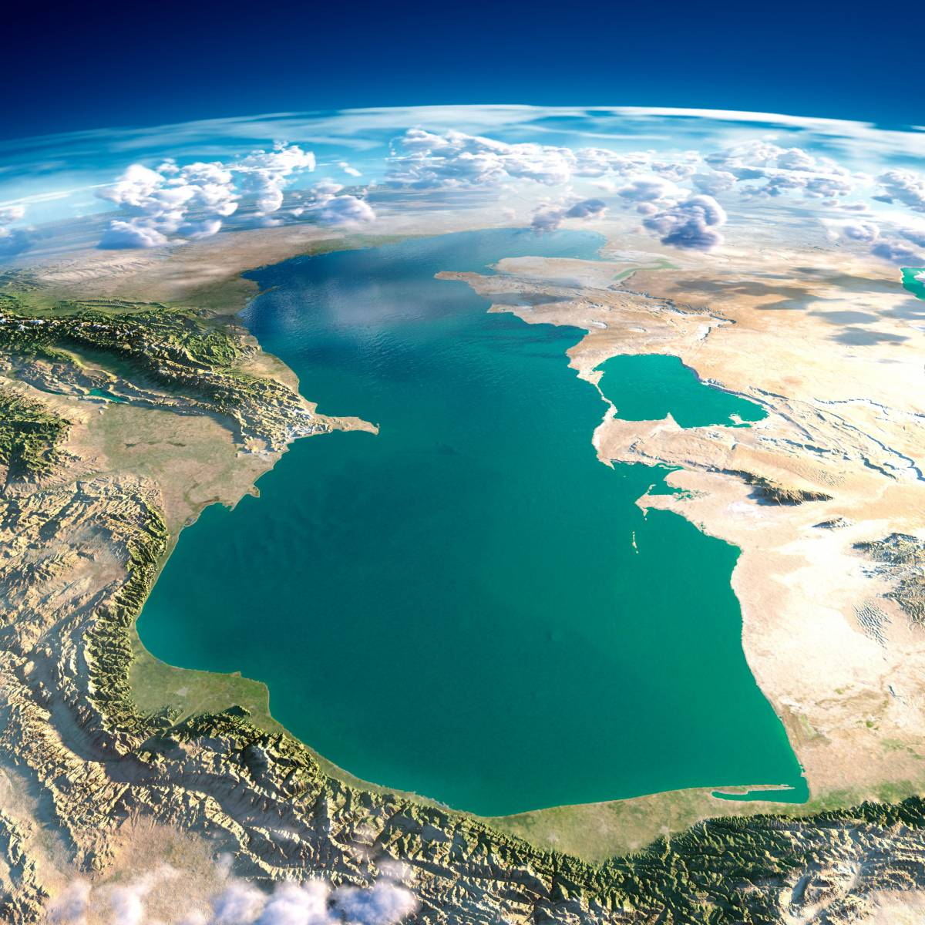
program
Meeting of the Commission
for Science, Research and
Technology at the Association of
Universities and
Research Centers
of the Caspian Region States
May 28, 2021
Astrakhan,
Russian Federation






PROGRAM
Meeting of the Commission for Science, Research and Technology at the Association of Universities and Research Centers of the Caspian Region States
May 28, 2021
10.30-11.00 | Registration
11.00-  12.15 | IntroductionandOpeningAddress  - Opening Message fromMarkelov Konstantin Alexeevich,Chairman of the Commission for Science, Research and Technology at the Association of Universities and Research Centers of the Caspian Region States, Rector ofthe Astrakhan State University, PhD in Economics, Professor  - Welcome Message from Ahmad Razi, President of the Association of Universities and Research Centers of the Caspian Region States, Chancellor of the University of Guilan(Islamic Republic of Iran), Professor(online)  - Welcome Message from Ovchinnikov Dmitry Evgenievich, Deputy Chairman of the Government of the Astrakhan Region  - Welcome Message from Mehdi Akuchekian, Consul General of the Islamic Republic of Iran in Astrakhan  - Welcome Message from UmbetbaevTauboldyBalkhiauly, Consul General of the Republic of Kazakhstan in Astrakhan  - Welcome Message from GaraevGuychArchaevich,Consul of Turkmenistan in the Russian Federation  - Welcome Message fromPoladBulbuloglu, Ambassador Extraordinary and Plenipotentiaryof the Republic of Azerbaijan to the Russian Federation  - Welcome Message from Pimenov Yuri Timofeevich, Executive Director of the Association of Universities and Research Centers of the Caspian Region States, D.Sc. in Chemistry, Professor  Track 1. Prospects for the development of the integration scientific and educational space of the Caspian region  Speakers:  - BehroozAbtahi, Director of theIranian National Institute for Oceanography and Atmospheric Science (INIOAS) (Islamic Republic of Iran)  «Creation of a unified database of scientists for the development of scientific cooperation “Caspian expert”»(online)  - Filimonov Alexey Vladimirovich, Executive Director of the National Association of Technology Transfer (Russian Federation)  «Development of cooperation between science and business. Technology transfer infrastructure»  - SorokotyagaYaroslavViktorovich, Head of the Department of International Programs of theRussian Foundation for Basic Research (RFBR)(Russian Federation)  «RFBR experience in supporting international scientific research in cooperation with science funding organizations from the Caspian countries»  - KurbanovRashadAfatovich, Advisor to the President of the Russian Academy of Sciences (RAS), Head of Institute of Legal Research and Regional Integration of thePlekhanov Russian University of Economics (Russian Federation)  «Promising areas of joint scientific research of the Russian Academy of Sciences and the National Academy of Sciences of Azerbaijan»(online)  - ZinnurovIrekKhaidarovich, Head of the Representative Office of Rossotrudnichestvo (Russian cooperation) in the Republic of Azerbaijan - the Russian Information and Cultural Centre in Baku (RICC) (The Republic of Azerbaijan)  «Features of Russian education export» (online)  - Ali Basti, President ofthe Guilan park of Science and Technology (Islamic Republic of Iran)  «Technology transfer experiencethe Guilan park of Science and Technology»(online)  - Polukhina Tatyana Sergeevna, Head of the Youth Project Office of the Astrakhan State Medical University of the Ministry of Health of the Russian Federation(Russian Federation)  «Interuniversity Center for youth initiatives in science and technology as a driver for the development of youth policy in the region»  Moderator:  - Pimenov Yuri Timofeevich, Executive Director of the Association of Universities and Research Centers of the Caspian Region States (Russian Federation)  Issues & Impact:  - creation and approval of a list of expert subcommittees on top issues for the Caspian macro-region;  - creationof unified databaseofscientists for the search for co-authors totakepartin international scientific projects according to the subcommissions approved by the Commission for Science, Research and Technology at the Association of Universities and Research Centers of the Caspian Region States;  - development of mechanisms for interaction between scientific and educational organizations - members of the Association of Universities and Research Centers of the Caspian Region States within the framework of joint scientific research. | ASU  Co-Working Centre "Boiling Point",  20a Tatischev Str., 3rd floor
12.15-12.30 | Refreshmentbreak | ASU,  20a Tatischev Str., 3rd floor
12.30-14.00 | Track 2. Scientific collaboration as a basis for sustainable development of the Caspian region. Creation of joint scientific projects and teams in priority areas for development and countering the main challenges in the Caspian region  Panel:  - MirhoseiniSayedziAldin, Vice-Rector for Science and Research, MajidVazifedoustr, Professor,Gilan University (Islamic Republic of Iran)(online)  - NuryberdyevNuryberdyGaryagdyevich, Vice-rector for Scientific work, Turkmen State University named afterMagtymguly(Turkmenistan)(online)  - Mahmoud Azizi, Director of the Office of International and Scientific Cooperation, Professor at Mazandaran University (Islamic Republic of Iran) (online)  - KanbetovAsylbekShakhmuradovich, Head of the Commercialization Center of NJSC "Atyrau Oil and Gas University named after Safi Utebayev" (Republic of Kazakhstan)(online)  - AlirezaShenavarMasouleh, Director ofInternational Sturgeon Research Institute (Islamic Republic of Iran) (online)  - AliyevaIrana, Vice-Rector for Science and Development; GuliyevNovruz, Head of the Department of Hotel and Restaurant Business of the Azerbaijan University of Tourism and Management (Republic of Azerbaijan) (online)  - IdrissovSalamatNurmukhanovich, Rector; BatryshevDidarGalymovich, Vice-Rector for Science and International Relations,Atyrau State University named after KhalelDosmukhamedov(Republic of Kazakhstan) (online)  - Bashkina Olga Alexandrovna, Rector; Samotruyeva Marina Aleksandrovna, Vice-Rector for Science and Innovation,Udochkina Larisa Al'bertovna, Head of the Department for International and Interregional Activities, Astrakhan State Medical University of the Ministry of Health of the Russian Federation (Russian Federation)  - ImankulovTimurSakenovich, Vice-Rector for Science - Vice President for Research and Development, Caspian University of Technology and Engineering named after Sh.Yessenov(Republic of Kazakhstan) (online)  - BayatRohulah, Vice-Rector for Science,Imam Khomeini International University (Islamic Republic of Iran) (online)  - Aliyev Fagan Gambaroglu, Head of the Department of Ecology, Azerbaijan University of Architecture and Construction (Republic of Azerbaijan) (online)  - Nevalenny Alexander Nikolaevich, Rector; MaksimenkoYuriyAleksandrovich, Vice-Rector for Research and Innovation, Astrakhan State Technical University (Russian Federation)  - Shipulin SergeyVictorovich, Deputy Head of the Branch; Barinova Victoria Vladimirovna, Head of the Aquaculture center; RazinkovVyacheslavPetrovich, Head of the Laboratory of Marine Fish; Vasilchenko Olga Mikhailovna, Head of the Fish Reproduction Laboratory, Volga-Caspian Branch of the FSBSI "VNIRO" (CaspNIRKH) (Russian Federation)  - RabazanovNuhkadiIbragimovich, Director, Biarslanov Ahmed Biysoltanovich, Deputy Director for Scientific work,Dagestan Federal Research Center of the Russian Academy of Sciences (The Republic of Dagestan, Russian Federation)  - Zolina Tatiana Vladimirovna, Rector; LezhninaYuliaArkadyevna, Vice-Rector for Scientific and International Activities, State Autonomous Educational Institution of Higher Education "Astrakhan State University of Architecture and Civil Engineering"  - PolyanskayaElinaViktorovna, First Vice Rector – Vice Rector for Strategic Development; Fedotova Anna Vladislavovna, Vice Rector for Research Activities; TitovAlekseiValerevich, Vice Rector for Digitalization, Innovations and Priority Projects,Astrakhan State University (Russian Federation)  - BadmaevaKermenEvgenyevna, Vice-Rector for Science and Strategic Development; NatyrovArkadyKanurovich, Dean of the Faculty of Agriculture; Kurepina Natalia Leonidovna, Professor; Nastinova Galina Erdneevna, Professor, Kalmyk State University named after B.B. Gorodovikov(Republic of Kalmykia, Russian Federation)  - Isrigova Tatyana Aleksandrovna, Vice-Rector - Head of Scientific and Innovation Department; DuissenbievaGulfiraMenlibievna, Head of the Department for the Implementation of Innovative Technologies, Dagestan State Agrarian University (The Republic of Dagestan, Russian Federation)(online)  - HajiyevAlimuradAkhmedovich, Head of the Department of Biology and Biodiversity, Director of the Institute of Ecology and Sustainable Development; MagomedovMagomed-RasulDibirovich, Corresponding Member of RAS, Head of the Department of Ecology, Dagestan State University(The Republic of Dagestan, Russian Federation)  - SurakatovNurmagomedSaypulaevich, Rector; Batmanov Edward Zagidinovich, Dean of the Transport Faculty of the Dagestan State Technical University(The Republic of Dagestan, Russian Federation)  - AsvarovNarimanAsvarovich, Rector of FSBEI HE "Dagestan State Pedagogical University"(The Republic of Dagestan, Russian Federation)  - ZharkikhLesyaIvanovna, researcher, professor; Shumovskaya Natalya Evgenievna, Head of the Department of Economics and Transport Management; Bicharova Maria Mikhailovna, Head of the Department of Humanities and English, Caspian Institute of Sea and River Transportnamed after General-Admiral F.M. Apraksin – the affiliation of Volga State University of Water Transport, the Federal State Budgetary Educational Institution of Higher Education (Russian Federation)(online)  Moderator:  - Markelov Konstantin Alexeevich, Chairman of the Commission for Science, Research and Technology at the Association of Universities and Research Centers of the Caspian Region States  Issues & Impact:  - creation of international scientific project teams for the implementation of projects aimed at sustainable development of the Caspian region  - adoption of the Minutes of the meeting of the Commission for Science, Research and Technology at the Association of Universities and Research Centers of the Caspian Region States. | ASU  Co-Working Centre "Boiling Point",  20a Tatischev Str., 3rd floor

